CMR INSTITUTE OF TECHNOLOGY

Affiliated to Visvesvaraya Technological University(VTU) Sri Nivasa Reddy Layout, AECS Layout,
Marathahalli,Bengaluru, Karnataka 560037



Department of Information Science and Engineering
MACHINE LEARNING LAB (BCSL606)
Extra Program
Academic Year : 2025-26

Semester-VI Scheme-2022

Extra Program 1: Develop a program to implement the Support Vector Machine (SVM) algorithm for binary classification. Use the Pima Indians Diabetes dataset for training and evaluation. Experiment with different kernel functions (linear, RBF, polynomial) and regularization parameters to find the best model.
Code:
import numpy as np import pandas as pd from sklearn import svm
from sklearn.model_selection import train_test_split from sklearn.preprocessing import StandardScaler from sklearn.metrics import accuracy_score
from sklearn.model_selection import GridSearchCV

# Load the Pima Indians Diabetes dataset
url = "https://raw.githubusercontent.com/jbrownlee/Datasets/master/pima- indians-diabetes.data.csv"
columns = ['Pregnancies', 'Glucose', 'BloodPressure', 'SkinThickness', 'Insulin', 'BMI', 'DiabetesPedigreeFunction', 'Age', 'Outcome']
data = pd.read_csv(url, names=columns)

# Split the data into features (X) and target (y)
X = data.iloc[:, :-1].values y = data.iloc[:, -1].values

# Normalize the features scaler = StandardScaler()
X_scaled = scaler.fit_transform(X)

# Split the data into training and testing sets (80% train, 20% test) X_train, X_test, y_train, y_test = train_test_split(X_scaled, y, test_size=0.2, random_state=42)

# Define the SVM models with different kernel functions kernels = ['linear', 'rbf', 'poly']
C_values = [0.1, 1, 10]

# Store results results = []


# Train and evaluate the models for kernel in kernels:
for C in C_values:
print(f"Training SVM with {kernel} kernel and C={C}...")

# Create and train the SVM model model = svm.SVC(kernel=kernel, C=C) model.fit(X_train, y_train)

# Predict on the test set y_pred = model.predict(X_test)

# Calculate accuracy
accuracy = accuracy_score(y_test, y_pred) results.append((kernel, C, accuracy))

# Find the best model
best_model = max(results, key=lambda x: x[2])

# Print results
print("\nModel Evaluation Results:") for result in results:
print(f"Kernel: {result[0]}, C: {result[1]}, Accuracy:
{result[2]:.4f}")

print("\nBest Model:")
print(f"Kernel: {best_model[0]}, C: {best_model[1]}, Accuracy:
{best_model[2]:.4f}")

Output

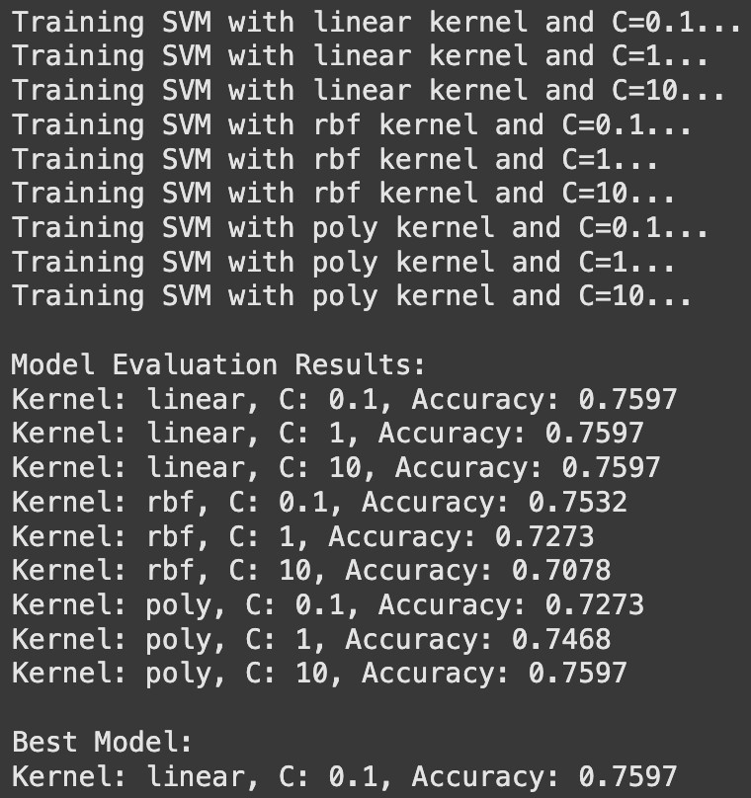

Extra Program 2: Develop a program to implement the AdaBoost algorithm for classification. Use the Pima Indians Diabetes dataset for training and evaluation. Analyze the impact of the number of weak learners on the model's performance and compare the performance of AdaBoost with a single decision tree classifier.
Code:
import numpy as np import pandas as pd
from sklearn.model_selection import train_test_split from sklearn.ensemble import AdaBoostClassifier
from sklearn.tree import DecisionTreeClassifier from sklearn.metrics import classification_report from sklearn.preprocessing import StandardScaler import matplotlib.pyplot as plt

# Load the dataset (Pima Indians Diabetes dataset)
url = "https://raw.githubusercontent.com/jbrownlee/Datasets/master/pima- indians-diabetes.data.csv"
column_names = ['Pregnancies', 'Glucose', 'BloodPressure', 'SkinThickness', 'Insulin', 'BMI', 'DiabetesPedigreeFunction', 'Age', 'Outcome']
data = pd.read_csv(url, names=column_names)

# Split into features and target
X = data.drop('Outcome', axis=1) y = data['Outcome']

# Normalize the data (important for algorithms like AdaBoost) scaler = StandardScaler()
X_scaled = scaler.fit_transform(X)

# Train-test split
X_train, X_test, y_train, y_test = train_test_split(X_scaled, y, test_size=0.2, random_state=42)

# Initialize the base classifier (Decision Tree) base_estimator = DecisionTreeClassifier(max_depth=1)

# AdaBoost with different numbers of weak learners (n_estimators) n_estimators_list = [10, 50, 100, 200]

adaboost_scores = []

for n_estimators in n_estimators_list:
# Train AdaBoost with the corrected parameter name 'estimator' adaboost = AdaBoostClassifier(estimator=base_estimator,
n_estimators=n_estimators, random_state=42) adaboost.fit(X_train, y_train)

# Evaluate the performance
y_pred_adaboost = adaboost.predict(X_test)
report = classification_report(y_test, y_pred_adaboost, output_dict=True)
adaboost_scores.append(report['accuracy']) # Collecting accuracy for comparison

# Evaluate performance of a single Decision Tree
single_tree = DecisionTreeClassifier(max_depth=1, random_state=42) single_tree.fit(X_train, y_train)
y_pred_tree = single_tree.predict(X_test)
single_tree_report = classification_report(y_test, y_pred_tree, output_dict=True)

# Display performance comparison between AdaBoost and Single Decision Tree print(f"Single Decision Tree Performance:\n{classification_report(y_test, y_pred_tree)}")
print("\nAdaBoost Performance with different numbers of weak learners:") for i, n_estimators in enumerate(n_estimators_list):
print(f"\nAdaBoost with {n_estimators} weak learners:") print(f"Accuracy: {adaboost_scores[i]}")

# Plot the impact of number of weak learners on AdaBoost's performance plt.plot(n_estimators_list, adaboost_scores, marker='o', label='AdaBoost') plt.axhline(y=single_tree_report['accuracy'], color='r', linestyle='--', label='Single Decision Tree')
plt.xlabel('Number of Weak Learners') plt.ylabel('Accuracy')
plt.title('Impact of Number of Weak Learners on AdaBoost Performance') plt.legend()
plt.show()

Output

